Q1.

Code:

require 'date'

# Generate a year's worth of random temperature data

def generate_temperature_data

  (1..365).map { rand(15..35) }

end

# Calculate the average temperature for the year

def average_temperature(temps)

  temps.sum / temps.size.to_f

end

# Find the hottest and coldest days of the year

def temperature_extremes(temps)

  hottest_day = temps.index(temps.max) + 1

  coldest_day = temps.index(temps.min) + 1

  [temps.max, hottest_day, temps.min, coldest_day]

end

# Calculate the average temperature for each month

def monthly_average(temps)

  days_in_month = [31, 28, 31, 30, 31, 30, 31, 31, 30, 31, 30, 31]

  month_starts = days_in_month.each_with_index.map { |days, i| days_in_month[0...i].sum }

  averages = []

  month_starts.each_with_index do |start_day, i|

    month_temps = temps[start_day, days_in_month[i]]

    averages << month_temps.sum / month_temps.size.to_f

  end

  averages

end

# Find the length of the longest heat wave

def longest_heat_wave(temps)

  max_length = 0

  current_length = 0

  temps.each do |temp|

    if temp > 30

      current_length += 1

      max_length = [max_length, current_length].max

    else

      current_length = 0

    end

  end

  max_length

end

# Find the length of the longest cold spell

def longest_cold_spell(temps)

  max_length = 0

  current_length = 0

  temps.each do |temp|

    if temp < 20

      current_length += 1

      max_length = [max_length, current_length].max

    else

      current_length = 0

    end

  end

  max_length

end

# Find the month with the highest average temperature

def hottest_month(temps)

  month_avgs = monthly_average(temps)

  hottest_month_index = month_avgs.index(month_avgs.max)

  hottest_month_index + 1 # months are 1-indexed

end

# Main Execution

temps = generate_temperature_data

puts "Average Temperature for the Year: #{average_temperature(temps).round(2)}°C"

hottest_temp, hottest_day, coldest_temp, coldest_day = temperature_extremes(temps)

puts "Hottest Temperature: #{hottest_temp}°C on Day #{hottest_day}"

puts "Coldest Temperature: #{coldest_temp}°C on Day #{coldest_day}"

monthly_avgs = monthly_average(temps)

puts "Monthly Averages: #{monthly_avgs.map { |avg| avg.round() }.join(', ')}"

puts "Longest Heat Wave Length: #{longest_heat_wave(temps)} days"

puts "Longest Cold Spell Length: #{longest_cold_spell(temps)} days"

puts "Hottest Month: #{hottest_month(temps)}"

Output:

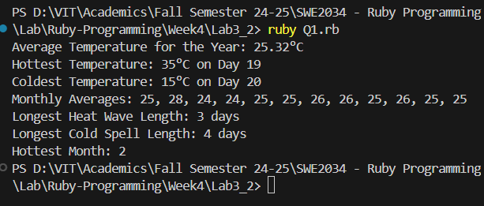

Q2.

Code:  
def find_head_number(array)

    return nil if array.length < 3

    (1...array.length - 1).each do |i|

      if array[i] > array[i - 1] && array[i] > array[i + 1]

        return array[i]

      end

    end

    nil

  end

  def find_master_pair(array)

    return nil if array.length < 2

    max_sum = 0

    best_pair = nil

    (0...(array.length - 1)).each do |i|

      ((i + 1)...array.length).each do |j|

        sum = array[i] + array[j]

        if sum > max_sum

          max_sum = sum

          best_pair = [array[i], array[j]]

        end

      end

    end

    best_pair

  end

  array = [1, 3, 2, 8, 5, 4, 10, 12, 53, 23, 25]

  head_number = find_head_number(array)

  master_pair = find_master_pair(array)

  puts "Head Number: #{head_number.inspect}"

  puts "Master Pair: #{master_pair.inspect}"

Output:

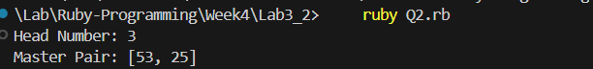

Q3.

Code:

class FactorialDispatcher

    def method_missing(method_name, *args)

      if method_name == :factorial

        handle_factorial(*args)

      else

        super

      end

    end

    def respond_to_missing?(method_name, include_private = false)

      method_name == :factorial || super

    end

    private

    def handle_factorial(n)

      if n.is_a?(Integer) && n >= 0

        result = factorial(n)

        puts "Result of factorial(#{n}): #{result}"

      else

        puts "Error: Factorial is only defined for non-negative integers."

      end

    end

    def factorial(n)

      (1..n).inject(:*) || 1

    end

  end

  dispatcher = FactorialDispatcher.new

  dispatcher.factorial(5)

  dispatcher.factorial(10)

  dispatcher.factorial(-1)

  dispatcher.factorial('a')

  puts dispatcher.respond_to?(:factorial)

  puts dispatcher.respond_to?(:non_existent)

Output

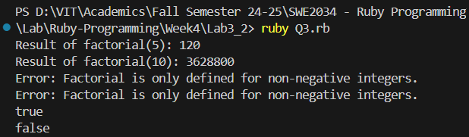

Q4.

Code:

def evaluate_expression(expression)

    begin

      eval(expression)

    rescue StandardError => e

      return nil

    end

  end

  def balanced_parentheses?(str)

    stack = []

    brackets = { '(' => ')', '{' => '}', '[' => ']', '<' => '>' }

    positions = []

    expression = ""

    str.each_char.with_index do |char, index|

      if brackets.keys.include?(char)

        stack.push(char)

        positions.push(index)

      elsif brackets.values.include?(char)

        last_open = stack.pop

        if last_open.nil? || brackets[last_open] != char

          return "Mismatch at position #{index + 1}"

        end

        positions.pop

      else

        expression << char unless char.match?(/[()\[\]{}<>]/)

      end

    end

    if stack.empty?

      result = evaluate_expression(expression.strip)

      return result.nil? ? true : result

    else

      return "Mismatch at position #{positions.last + 1}"

    end

  end

  puts balanced_parentheses?("(1+2)*{3+4}")

  puts balanced_parentheses?("a ( b c ) d")

  puts balanced_parentheses?("{[<>]}")

  puts balanced_parentheses?("{[>]}")

Output:

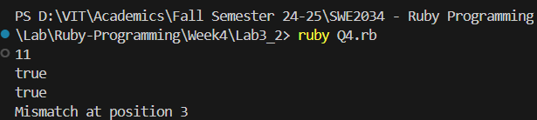

Q5.

TextFile:

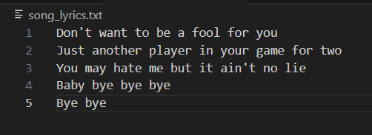

Code:

def word_frequency(file_path)

    word_count = Hash.new(0)

    text = File.read(file_path)

    words = text.downcase.scan(/\b[\w']+\b/)

    words.each { |word| word_count[word] += 1 }

    word_count.each { |word, count| puts "#{word}: #{count}" }

    most_frequent_word = word_count.max_by { |_, count| count }

    puts "\nMost frequently used word: '#{most_frequent_word[0]}' appears #{most_frequent_word[1]} times"

  end

  word_frequency('song_lyrics.txt')

Output:

